Phonetic transcription:-

A phonetic transcription looks quite unlike a regular (‘orthographic’) transcription. The transcriber notes the way the spoken words are pronounced, using a special alphabet of phonetic symbols. The most common is the International Phonetic Alphabet (IPA).

You have probably seen IPA symbols in dictionaries. Printed between a word and its definition, you’ll find something like this:

ˈɔː.di.əʊ

This is a phonetic spelling of “audio.” Like many English-language words, it is not obvious how to say “audio” if you are not a native speaker. But, when transcribed phonetically, each sound in the word is represented by a symbol. Non-English speakers who know how to read ipa can read back a phonetic transcription with the correct english pronunciation, even if they don’t know the meaning. In fact, ipa works for every spoken language, not just English.

Here is an [example](https://fonetika.ff.cuni.cz/studium/stranky-kurzu/english-phonetics-phonology/transcription-exercises/) of what the phonetic transcription of a full sentence looks like:

Hi ˈhæd‿ɪz ˈfɑːðəz‿ˈɪəz‿ ǀ ‿ənd‿ɪz ˈmʌðəz‿ˈəʊpn̩ ˈhɑːt ǁ

Can’t make head nor tail of it? Here’s the orthographic transcription of the same sentence:

“He had his father’s ears and his mother’s open heart.”

As you can see, they are very different texts that have very different uses.

Phonetic transcription of 20 words are given below:-

|  |  |  |
| --- | --- | --- |
| S.no. | word | transcription |
| 1. | Class | /'klɑ:s/ |
| 2. | Hello | /hə'ləʊ/ |
| 3. | Kitchen | /'kɪtʃɪn/ |
| 4. | Mark | /'mɑ:k/ |
| 5. | Please | /'pli:z/ |
| 6. | Quite | /'kwaɪt/ |
| 7. | Age | /'eɪdʒ/ |
| 8. | Inside | /ˌɪn'saɪd/ |
| 9. | Paper | /'peɪpə/ |
| 10. | Happy | /'hæpɪ/ |
| 11. | Proper | /'prɒpə/ |
| 12. | Queen | /'kwi:n/ |
| 13. | Fact | /'fækt/ |
| 14. | Get | /'get/ |
| 15. | Add | /'æd/ |
| 16. | Cold | /'kəʊld/ |
| 17. | Lazy | /'leɪzɪ/ |
| 18. | Want | /wɔnt/ |
| 19. | Rough | /rɐf/ |
| 20. | Thing | /θɪng/ |

Chart :- chart is given below :)

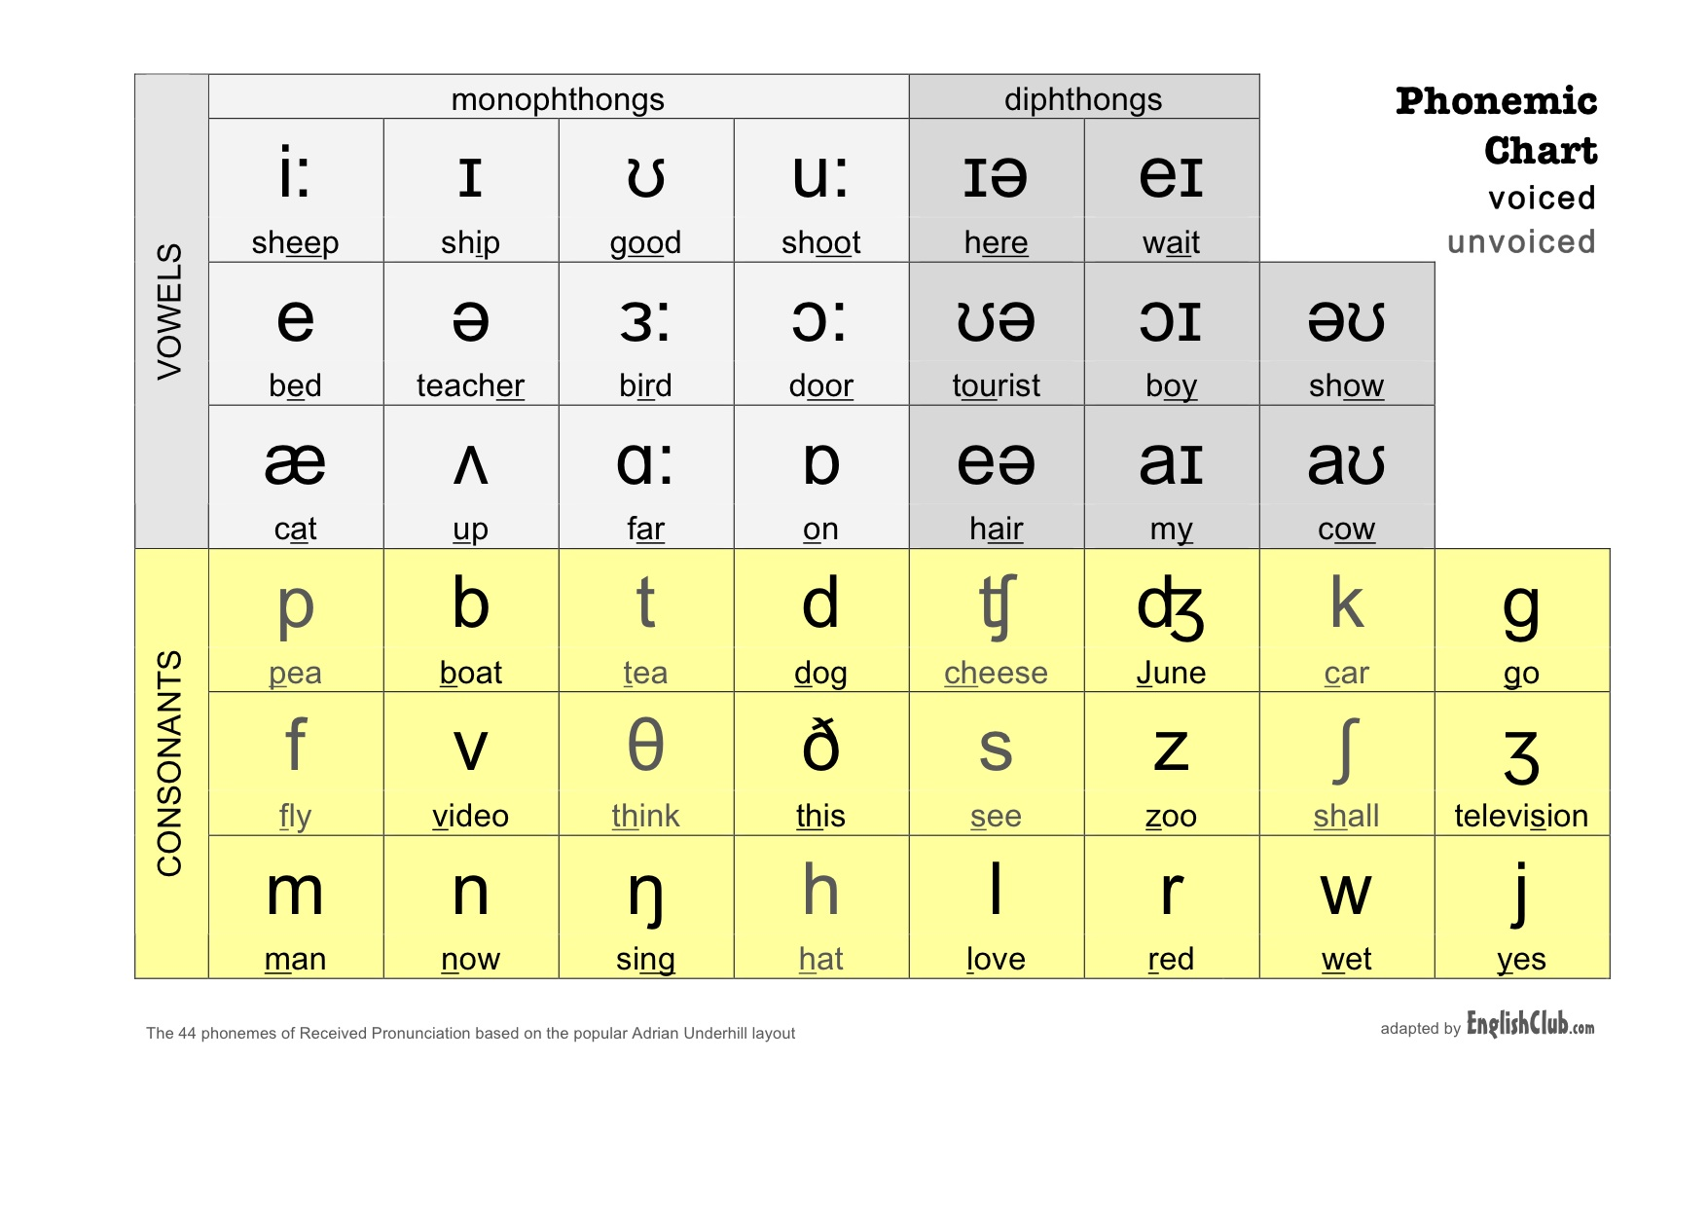

What is intonation?

In [linguistics](https://en.wikipedia.org/wiki/Linguistics), intonation is variation in spoken [pitch](https://en.wikipedia.org/wiki/Pitch_(music)) when used, not for distinguishing words as [sememe](https://en.wikipedia.org/wiki/Sememe) (a concept known as [tone](https://en.wikipedia.org/wiki/Tone_(linguistics))), but, rather, for a range of other functions such as indicating the attitudes and emotions of the speaker, signaling the difference between statements and questions, and between different types of questions, focusing attention on important elements of the spoken message and also helping to regulate conversational interaction. (The term tone is used by some British writers in their descriptions of intonation but to refer to the pitch movement found on the nucleus or tonic syllable in an intonation unit.)

Although intonation is primarily a matter of pitch variation, it is important to be aware that functions attributed to intonation such as the expression of attitudes and emotions, or highlighting aspects of grammatical structure, almost always involve concomitant variation in other [prosodic](https://en.wikipedia.org/wiki/Prosody_(linguistics)) features. David crystal for example says that "intonation is not a single system of contours and levels, but the product of the interaction of features from different prosodic systems – tone, pitch-range, loudness, rhythmicality and tempo in particular.

What is usage of intonation?

**Intonation**, in phonetics, the melodic pattern of an utterance. Intonation is primarily a matter of variation in the [pitch](https://www.britannica.com/topic/pitch-speech) level of the [voice](https://www.britannica.com/science/vocalization) (see also [tone](https://www.britannica.com/topic/tone-speech)), but in such languages as English, [stress](https://www.britannica.com/topic/stress-linguistics) and rhythm are also involved.

Intonation conveys differences of expressive meaning (e.g., surprise, anger, wariness).

In many languages, including English, intonation serves a grammatical function, distinguishing one type of phrase or sentence from another.

Thus, “your name is john,” beginning with a medium pitch and ending with a lower one (falling intonation), is a simple assertion; “your name is john?” with a rising intonation (high final pitch), indicates a [question](https://www.britannica.com/topic/question).

What is word stress?

In [linguistics](https://en.wikipedia.org/wiki/Linguistics), and particularly [phonology](https://en.wikipedia.org/wiki/Phonology), stress or accent is the relative emphasis or prominence given to a certain [syllable](https://en.wikipedia.org/wiki/Syllable) in a [word](https://en.wikipedia.org/wiki/Word) or to a certain word in a phrase or [sentence](https://en.wikipedia.org/wiki/Sentence_(linguistics)). That emphasis is typically caused by such properties as increased [loudness](https://en.wikipedia.org/wiki/Loudness) and [vowel length](https://en.wikipedia.org/wiki/Vowel_length), full articulation of the [vowel](https://en.wikipedia.org/wiki/Vowel), and changes in [tone](https://en.wikipedia.org/wiki/Tone_(linguistics)) the terms stress and accent are often used synonymously in that context but are sometimes distinguished. For example, when emphasis is produced through pitch alone, it is called [pitch accent](https://en.wikipedia.org/wiki/Pitch-accent_language), and when produced through length alone, it is called quantitative accent. When caused by a combination of various intensified properties, it is called stress accent or dynamic accent; English uses what is called variable stress accent.

Since stress can be realized through a wide range of [phonetic](https://en.wikipedia.org/wiki/Phonetics) properties, such as loudness, vowel length, and pitch (which are also used for other linguistic functions), it is difficult to define stress solely phonetically.

The stress placed on [syllables](https://en.wikipedia.org/wiki/Syllable) within words is called word stress or lexical stress. Some languages have fixed stress, meaning that the stress on virtually any multisyllable word falls on a particular syllable, such as the [penultimate](https://en.wikipedia.org/wiki/Penult) (e.g. [Polish](https://en.wikipedia.org/wiki/Polish_language)) or the first (e.g. [Finnish](https://en.wikipedia.org/wiki/Finnish_language)). Other languages, like [english](https://en.wikipedia.org/wiki/Stress_and_vowel_reduction_in_English" \o "Stress and vowel reduction in English) and [russian](https://en.wikipedia.org/wiki/Russian_language" \o "Russian language), have variable stress, where the position of stress in a word is not predictable in that way. Sometimes more than one level of stress, such as primary stress and [secondary stress](https://en.wikipedia.org/wiki/Secondary_stress), may be identified.

Stress is not necessarily a feature of all languages: some, such as [French](https://en.wikipedia.org/wiki/French_language) and [mandarin](https://en.wikipedia.org/wiki/Standard_Chinese_phonology), are sometimes analyzed as lacking lexical stress entirely.

The stress placed on words within sentences is called sentence stress or prosodic stress. That is one of the three components of [prosody](https://en.wikipedia.org/wiki/Prosody_(linguistics)), along with [rhythm](https://en.wikipedia.org/wiki/Isochrony) and [intonation](https://en.wikipedia.org/wiki/Intonation_(linguistics)). It includes phrasal stress (the default emphasis of certain words within [phrases](https://en.wikipedia.org/wiki/Phrase_(linguistics)) or [clauses](https://en.wikipedia.org/wiki/Clause)), and contrastive stress (used to highlight an item, a word or part of a word, that is given particular focus).

What is the usage of word stress?

Word stress is not used in all languages. Some languages, Japanese or French for example, pronounce each syllable with eq-ual em-pha-sis.

Other languages, English for example, use word stress and pro-nounce dif-fer-ent syl-la-bles with more or less im-por-tance.

Word stress is not an optional extra that you can add to the English language if you want. It is **part of the language**! Fluent English speakers use word stress to communicate rapidly and accurately, even in difficult conditions. If, for example, you do not hear a word clearly, you can still understand the word because of the position of the stress.

Think again about the two words photograph and photographer. Now imagine that you are speaking to somebody by telephone over a very bad line. You cannot hear clearly. In fact, you hear only the first two syllables of one of these words, photo... Which word is it, photograph or photographer?

Of course, with word stress you will know immediately which word it is because in reality you will hear either...

**BIBLIOGRAPHY**

1. Phonetic Transcription :- <https://en.wikipedia.org/wiki/Phonetic_transcription>

<http://www.phonemicchart.com/transcribe/1000_basic_words.html>

1. Chart :- <https://www.englishclub.com/pronunciation/phonemic-chart.htm>
2. Intonation & usage :- <https://en.wikipedia.org/wiki/Intonation_(linguistics)>

<https://www.britannica.com/topic/intonation>

1. Word Stress & usage :- <https://en.wikipedia.org/wiki/Stress_(linguistics)>

<https://www.englishclub.com/pronunciation/word-stress-why.htm>